|  |  |
| --- | --- |
| Campus Libraries | Princeton School of Public and International Affairs  **LIBRARY MANAGEMENT SYSTEM** | **GROUP MEMBERS:**  **MUHAMMAD MASOOD KHAN**  **SOFIA AAMIR**  **MAHNOOR QAZI**  **REGISTRATION NO:**  **FA21-BSE-028**  **FA21-BSE-036**  **FA21-BSE-020**  **SUBMITTED TO:**  **RAB NAWAZ JADOON** |

Table of Contents

**1. Introduction** 4

**1.1 Relevance Modules** 4

**1.2 Project Background** 4

**1.3 Literature Review** 4

**Current Trends in Libraries:** 4

**User Engagement:** 5

• **Current Research and Product in Libraries:** 5

**2. Problem Definition** 6

**2.1 Problem Statement** 6

**2.2 Proposal** 7

**3. ERD Diagram** 8

**3.1 Level 0 ERD Diagram** 8

**3.1.1 Description:** 8

**3.1.2 Entities:** 8

**3.1.3 Diagram:** 8

**3.2 Level 1 ERD Diagram** 9

**3.2.1 Relations:** 9

**3.2.2 Diagram:** 10

**3.3 Level 2 ERD Diagram** 10

**3.3.1 Resolve Many to Many Relations Of ERD:** 10

**3.3.2 Diagram** 11

**3.4 ERD Diagram After Normalization** 11

**3.4.1 Description:** 11

**3.4.2 Diagram:** 12

**4. Normalization** 13

**5. Translation Schema** 16

**REPOSITORY LINK:**

[**https://github.com/Masoodkhan5933/LIBRARY_MANAGEMENT_SYSTEM-DATABASE**](https://github.com/Masoodkhan5933/LIBRARY_MANAGEMENT_SYSTEM-DATABASE)

**EXECUTIVE SUMMARY**

The management of libraries has evolved significantly with the advent of digital resources and the increasing demand for efficient and user-friendly services. Implementing a Library Management System (LMS) offers a comprehensive solution to overcome challenges faced by libraries in today's digital era.

Our proposed Library Management System aims to streamline operations, enhance user experiences, and optimize resource management for libraries of all sizes. The system provides a centralized platform for cataloging, circulation, and resource tracking, enabling efficient administration and improved accessibility for library staff and patrons.

Key features of the Library Management System include an integrated cataloging module that automates the process of adding and organizing library resources. This module ensures accurate data entry, enables quick search and retrieval of materials, and reduces human errors associated with manual cataloging.

The circulation management component of the system automates tasks such as checkouts, returns, and renewals. It provides a seamless borrowing experience for library patrons, with self-service options, online reservations, and real-time availability updates. This feature not only improves efficiency but also enhances user satisfaction and engagement.

Additionally, the LMS includes a user-friendly online portal where patrons can access digital resources, browse the library's catalog, and manage their accounts. The portal enables users to place holds, view reading history, and receive personalized recommendations, enhancing their overall library experience.

The Library Management System also offers robust reporting and analytics capabilities, empowering library administrators with data-driven insights. These insights enable informed decision-making regarding resource allocation, collection development, and service improvements. Usage statistics, circulation patterns, and user feedback can be leveraged to optimize library operations and meet evolving user needs.

Furthermore, the system prioritizes data security and privacy. It incorporates robust access controls, encryption protocols, and backup mechanisms to safeguard sensitive user information and library data. Compliance with data protection regulations is ensured, instilling trust and confidence among library users.

In conclusion, the proposed Library Management System presents a comprehensive solution to the challenges faced by modern libraries. By leveraging technology, libraries can streamline operations, improve accessibility, and enhance user experiences. The system's integrated cataloging, circulation management, online portal, and data analytics capabilities provide an efficient and user-centric approach to library management. Implementing this system will empower libraries to adapt to changing user expectations, optimize resource utilization, and thrive in the digital age.

# **1. Introduction**

Our project focuses on implementing a robust Library Management System (LMS) to address the challenges faced by library managers in effectively handling their book inventory and ensuring up-to-date information. The LMS software serves as a comprehensive solution that empowers library managers to efficiently manage their library resources.

## **1.1 Relevance Modules**

Our project focuses on implementing a comprehensive Library Management System (LMS) by utilizing various concepts of database systems. This project covers key aspects of data modeling, including the development of an Entity-Relationship Diagram (ERD), normalization techniques, and the creation of a well-structured database schema.

## **1.2 Project Background**

A Library management system is an application which refers to library system which are generally small or medium in size. It is used by librarian to manage libraries using a computerized system where he/she can record various transactions like borrow book, book loan and there are different tables in our project like book, publisher, book copies, book authors, branches and many more.

Books and students maintenance modules are also included in this system which would keep track of the students using a library and also a detailed description about the books a library contained. With the computerized system there will be no loss of data about the accounts registered and books which generally happens when a non-computerized system is used.

All the modules help the librarian to store the store and manage the library in more convenient and efficient way as compare to other libraries systems which are not computerized.

## **1.3 Literature Review**

### **Current Trends in Libraries:**

The latest trends in Library and Information Science (LIS) include **advances in collection management, user engagement and security (SSO).**

**Collection Management:**

Collection management is the term most commonly used to describe the area of librarianship that deals with collections. Collection management incorporates the variety of functions involved in selecting, acquiring, storing and maintaining collections in a cost-effective manner.

**User Engagement:**

User engagement measures whether users find value in a product or service. Engagement can be measured by a variety or combination of activities such as downloads, clicks, shares, and more.

**Security:**

Using library security is **one technique for protecting information while maintaining a simple security scheme**. For example, to secure confidential information for a set of applications, you can do the following actions: Use a library to store all confidential files for a particular group of applications.

### **Current Research and Product in Libraries:**

The current research related to Libraries was on 6th July, 2022. The library will be implementing a new Library System. This research describes what is changing, the benefits and what you need to do.

The current product used in Libraries is Radio Frequency Identification (RFID) use electromagnetic fields to automatically identify and track tags attached to books. There are several ways of identifying tags but the most common is to store a serial number.

# **2. Problem Definition**

Non-computerized system of keeping student records, book record, and account details is very difficult. There are various problems also faced by the students in library such as finding any particular book, information whether book is available or not, for what time this book will be available and also found difficulty in searching of book by id number. To eliminate these problems this computerized library management systems are developed. It will handle all the current issues faced by students and admin.

## **2.1 Problem Statement**

In our existing system all the transaction of books are done manually. So, after doing the feasibility study we decided to change our manual system to automated library management system. Through our software we can simply add members, search for books, add books, update information, borrow and return the book in quick time. Our proposed system has following advantages:

* Fast access to database
* Less error
* More storage capacity
* Quick transaction

All the manual difficulties in managing the library have been rectified by implementing computerization.

Among the main challenges faced by library management system are:

1. Problems with network connectivity.
2. Power fluctuation and adequate staff with ICT skills.
3. Content may be subject to copyright.
4. Financial drawback is one of the main reasons. To implement the sophisticated technology, we need to invest more.

People need to be educated in technology.

In online there is no human interaction if users have some enquiry.

1. Absence of planning.
2. Online data stored is predisposed to cyber hacks.
3. Sometimes it is complicated to first time users.
4. More numbers of computers should require.
5. Inadequate security procedures.
6. Poor funding.

## **2.2 Proposal**

The proposed project aims to develop a comprehensive Library Management System specifically designed to address the challenges faced by libraries in managing their resources efficiently. The system will transition from traditional manual processes to a digital platform, streamlining operations, enhancing productivity, and improving data accuracy.

The Library Management System will provide a centralized platform for librarians, administrators, and library users to access real-time information and resources. It will enable librarians to manage the library's collection effectively, track book availability, and automate routine tasks such as cataloging, circulation, and inventory management.

The proposed system will also offer user-friendly features for library users. A user portal will provide easy access to the library's catalog, allowing users to search for books, reserve materials, and view their borrowing history. This feature will enhance user experiences and empower library users to make the most of the library's resources.

The software requirements for the project include a robust database management system, such as MySQL or Oracle, to efficiently store and retrieve library data. Additionally, a software modeling tool like Star UML will be utilized for the design and development of the system.

In conclusion, the proposed Library Management System aims to revolutionize library operations, improve data accuracy, and increase productivity within the library. By transitioning to a digital platform, the system will enhance transparency, streamline processes, and provide valuable insights for decision-making. Ultimately, the implementation of this system will result in an efficient, user-centric library experience for both librarians and library users.

# **3. ERD Diagram**

## **3.1 Level 0 ERD Diagram**

### **3.1.1 Description:**

In Library management system (LMS), there is an administrator. He manages all books in library on daily basis. There are books in library which are written by author and publish by any publisher so there is also a list of authors and publishers. The books present in library has different categories. The users can access the library and they can perform different operations like borrow and reserve book for themselves.

### **3.1.2 Entities:**

* Book
* Author
* Categories
* Publisher
* Borrowbooklist
* User
* Admin

### **3.1.3 Diagram:**

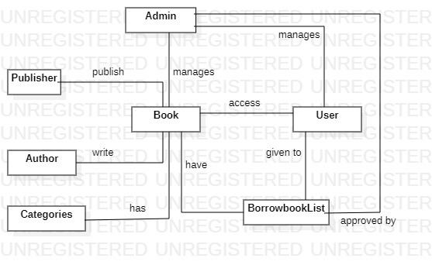

## **3.2 Level 1 ERD Diagram**

### **3.2.1 Relations:**

1. **Book and Author:**

**Many-to-Many Relationship**:

A book can have multiple authors, and an author can write multiple books.

1. **Book and Publisher:**

**Many-to-One Relationship:**

A book is published by a single publisher, but a publisher can publish multiple books.

1. **Book and Borrow-Book:**

**One-to-Many Relationship:**

No book can be borrowed or many book can be borrowed, Each borrow transaction will be associated with a specific book.

1. **Admin and Book:**

**One-to-Many Relationship:**

An admin can manage multiple books, and a book can be managed by single admin.

1. **Book and Category:**

**Many-to-Many Relationship:**

A book can belong to multiple categories, and a category can have multiple books.

1. **Book and User:**

**Many-to-Many Relationship:**

A book can use by many users and a user can use many books at a time.

1. **User and Admin:**

**Many-to-One Relationship:**

A user is manage by single admin, and an admin can manage multiple users at a time.

1. **Admin and Borrow-Book:**

**One-to-Many Relationship:**

A single admin can approve multiple borrow book list and a multiple borrow book list is approve by single admin.

### **3.2.2 Diagram:**

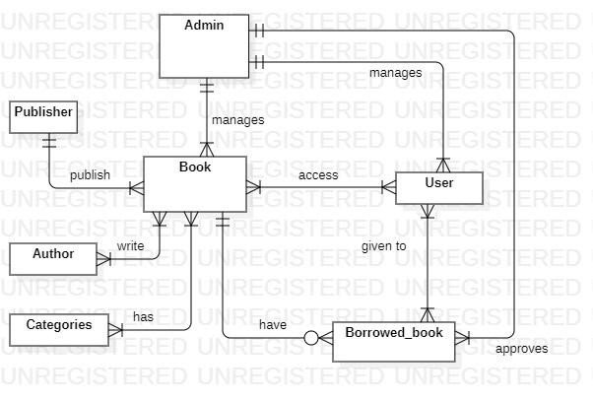

## **3.3 Level 2 ERD Diagram**

### **3.3.1 Resolve Many to Many Relations Of ERD:**

The above description is level 0 of the library management system, It contains many to many relations between entities so to solve those many to many relations we will draw level 1 by entering the gerund entities between those entities which have many to many relations. We will just insert the gerund entity between those entities which have many to many relations and then we will put the primary keys of both the entities into the gerund entity as foreign key .

### **3.3.2 Diagram**

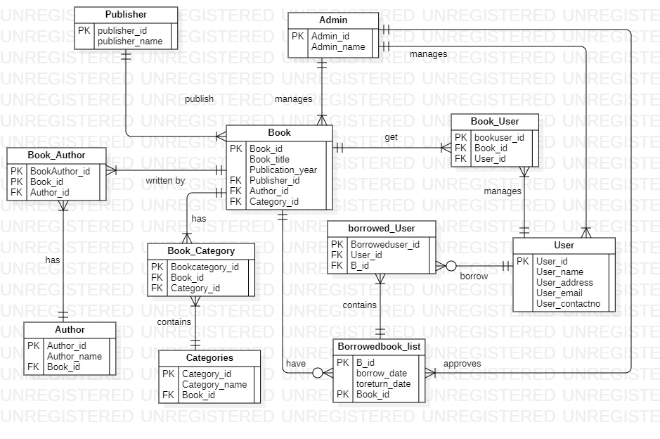

## **3.4 ERD Diagram After Normalization**

### **3.4.1 Description:**

This is the final version of ER diagram that was made after normalization, the need that was felt to make it was that the number of entities increased after normalization.

### **3.4.2 Diagram:**



# **4. Normalization**

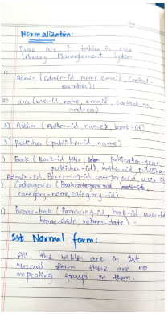

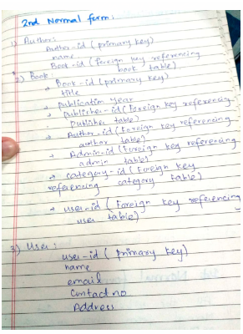

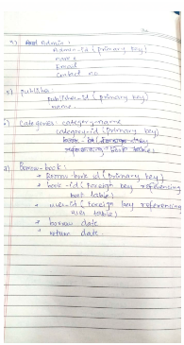

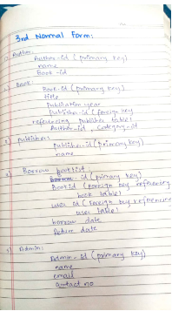

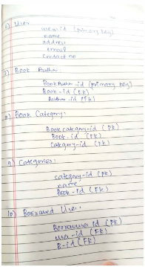

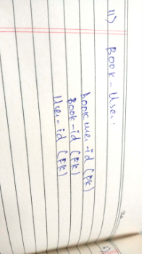

# **5. Translation Schema**

**1-Table Name:** Admin

**Primary key:** Admin-id

**Description:** This table used to store the names of all Admins.

|  |  |  |  |
| --- | --- | --- | --- |
| **Field Name** | **Data Type** | **Size** | **Description** |
| Admin-Id | INT |  | Admin no |
| name | VARCHAR | 50 | Name of Admin |

**2-Table Name:** Book

**Primary key:** Book-id

**Foreign key**: Publisher-id, Author-id, Category-id

**Description:** This table used to store the names of all Books.

|  |  |  |  |
| --- | --- | --- | --- |
| **Field Name** | **Data Type** | **Size** | **Description** |
| Book-Id | INT |  | Book no |
| title | VARCHAR | 50 | Name of book |
| Publication-year | INT |  | Book publish year |
| Publisher-id | INT |  | Publisher no |
| Author-id | INT |  | Author no |
| Category-id | INT |  | Category no |

**3-Table Name:** Author

**Primary key:** Author-id

**Foreign key**: Book-id

**Description:** This table used to store the names of all authors.

|  |  |  |  |
| --- | --- | --- | --- |
| **Field Name** | **Data Type** | **Size** | **Description** |
| Author-Id | INT |  | Author no |
| name | VARCHAR | 50 | Name of author |
| Book-id | INT |  | Book no |

**4-Table Name:** Publisher

**Primary key:** Publisher-id

**Description:** This table used to store the names of all publishers.

|  |  |  |  |
| --- | --- | --- | --- |
| **Field Name** | **Data Type** | **Size** | **Description** |
| Publisher-Id | INT |  | Publisher no |
| Publisher-name | VARCHAR | 50 | Name of publisher |

**5-Table Name:** User

**Primary key:** User-id

**Description:** This table used to store the names of all Users.

|  |  |  |  |
| --- | --- | --- | --- |
| **Field Name** | **Data Type** | **Size** | **Description** |
| User-Id | INT |  | User no |
| User-name | VARCHAR | 50 | Name of user |
| User-email | VARCHAR | 50 | User email |
| User-address | VARCHAR | 50 | Address of user |
| User-contact no | VARCHAR | 15 | Contact no of user |

**6-Table Name:** Categories

**Primary key:** Category-id

**Foreign key:** Book-id

**Description:** This table used to store the categories of all books.

|  |  |  |  |
| --- | --- | --- | --- |
| **Field Name** | **Data Type** | **Size** | **Description** |
| category-Id | INT |  | category no |
| category-name | VARCHAR | 50 | Name of category |
| Book-id | INT |  | Book no |

**7-Table Name:** Book Author

**Primary key:** Book Author-id

**Foreign key:** Author-id, Book-id

**Description:** This table used to store the names of all book authors.

|  |  |  |  |
| --- | --- | --- | --- |
| **Field Name** | **Data Type** | **Size** | **Description** |
| Book author-Id | INT |  | Book author no |
| Book-id | INT |  | Book no |
| Author-id | INT |  | Author no |

**8-Table Name:** Book category

**Primary key:** book category-id

**Foreign key:** category-id, Book-id

**Description:** This table used to store the names of all book categories.

|  |  |  |  |
| --- | --- | --- | --- |
| **Field Name** | **Data Type** | **Size** | **Description** |
| Book category-Id | INT |  | Book category no |
| Book-id | INT |  | Book no |
| category-id | INT |  | category no |

**9-Table Name:** Book user

**Primary key:** bookuser-id

**Foreign key:** user-id, Book-id

**Description:** This table used to store the names of all book users.

|  |  |  |  |
| --- | --- | --- | --- |
| **Field Name** | **Data Type** | **Size** | **Description** |
| Book user-Id | INT |  | Book userno |
| Book-id | INT |  | Book no |
| user-id | INT |  | User no |

**10-Table Name:** borrowed-user

**Primary key:** borroweduser-id

**Foreign key:** user-id,B-id

**Description:** This table used to store the names of all borrow book users.

|  |  |  |  |
| --- | --- | --- | --- |
| **Field Name** | **Data Type** | **Size** | **Description** |
| borroweduser -Id | INT |  | Borrow user no |
| user-id | INT |  | user no |
| B-id | INT |  | Borrow book list no |

**11-Table Name:** borrowedbook-list

**Primary key:** B-id

**Foreign key:** Book-id

**Description:** This table used to store the names of all borrow book list.

|  |  |  |  |
| --- | --- | --- | --- |
| **Field Name** | **Data Type** | **Size** | **Description** |
| B-Id | INT |  | Borrow book list no |
| Borrow date | INT |  | Borrow date of book |
| Return date | INT |  | Return date of book |
| Book-id | INT |  | Book-no |